Acute Abdominal Pathway

This pathway for ALL patients with acute abdominal conditions that may require surgery. Request Forms Should contain the words ‘Acute Abdominal Pathway’ in a circle.

1. Emergency Assessment and Resuscitation
• NEWS within 30 minutes of admission to Hospital
• FBC/U+E/LFT/CRP/Clotting/Amylase/G+S (Results available <30 Mins)
• Identification of Sepsis and implementation of Sepsis 6 Pathway
• Delivery of appropriate antibiotics within 1 hour of Sepsis diagnosis

2. Acute Surgical Referral

•Referral for Surgical team review within 2 hours of admission
•Immediate Escalation to Senior Surgeon if criteria fulfilled

3. Rapid Diagnosis and Surgical Plan
• Senior Surgical review within 1 hour of Escalation
• ITU/Anaesthetic review if patient shocked or surgery planned
• Rapid CT scan (if required) <1 hour from request
• Verbal report of CT to Consultant Surgeon ( <1 hour from CT Scan)

4. Emergency Theatre Provision
• Consultant Involvement in Perioperative Care including P-POSSUM calculation
NCEPOD classification:
Immediate (within minutes) Urgent (within hours) Expedited (within days)
•< 6 Hours from admission to theatre for Urgent/Emergency cases (<3 Hours if Septic Shock)
• Prioritisation of Theatre – next available slot on CEPOD/ Interruption of Elective Operating List

5. Intra-Operative Care
Date and time booked for theatre: / / (dd/mm/yyyy) / (hh:mm)
ASA: 1 2 3 4 5

Patient been reviewed by Consultant Anaesthetist Yes No if yes, (dd/mm/yyyy) / (hh:mm)

Date and time of entry in to the operating theatre (Not theatre suite): (dd/mm/yyyy) / (hh:mm)

Most senior surgeon present: Consultant Post CCT fellow SAS grade Specialty trainee (ST) Core trainee (CT)

Most senior anaesthetist present: Consultant Post CCT fellow SAS grade Specialty trainee (ST) Core trainee (CT)

Name of the consultant surgeon?

Name of the consultant anaesthetist?

Is this procedure, first surgical procedure after admission OR complication of previous surgery within the same admission

Indication for the surgery (Please select all that apply):

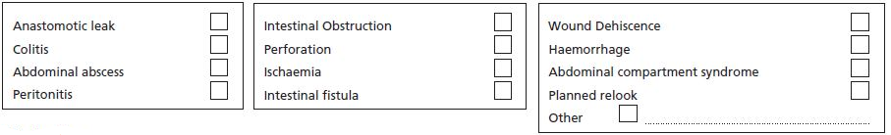

Monitoring

(Invasive monitoring recommended for patients >60yrs, ≥ASA 3 and immediate surgery; OR if estimated mortality > 10%)
Arterial Line Central venous catheter
Goal directed fluid therapy provided? Not provided
Cardiac output monitor Other
(Routine use of the technique is recommended for emergency laparotomy)

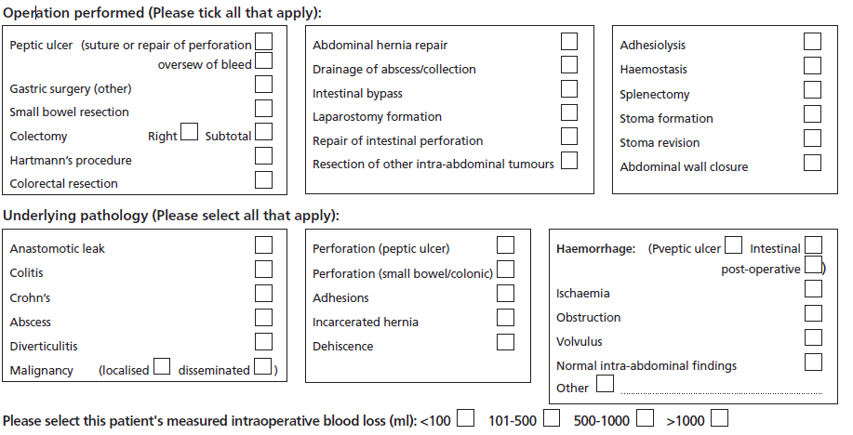

6. Postoperative ICU for patients with predicted mortality >10%
Post-operative Risk assessment

Was the patient classified as high risk at the end of the surgery? Yes No

How was the risk assessment performed at the end of the procedure?

P-POSSUM score calculated at the end of the procedure: Yes No
if yes, predicted mortality: % predicted morbidity: %

Immediate Post-operative Care
Post-op location:
Level 3 (ICU) Level 2 (HDU) Level 1 (Ward) Extended Recovery/PACU (Overnight stay)

Acute Abdominal Pathway

Target | Admission dd/mm/yy HH:MM | Recorded times dd/mm/yy HH:MM
A&E Review and management
30min | NEWS
60min | Identification of sepsis and antibiotic delivery
2hrs | Referral to surgical team
Diagnosis
1hr | CT booked and performed
1hr | CT scan reported
5hrs (after admission) | Surgical Decision
6hrs (after admission) | Theatre  Time booked  Time anaesthesia started
Management in theatre
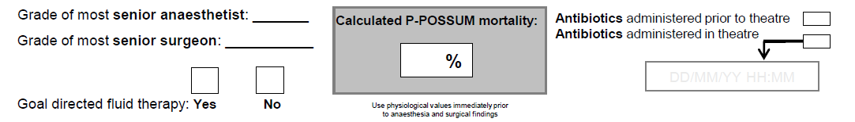
Destination from theatre
Calculated P-POSSUM mortality  10% - Refer to ICU Calculated P-POSSUM mortality < 10% - Consider ward management but refer to ICU at discretion of anaesthetist or surgeon

